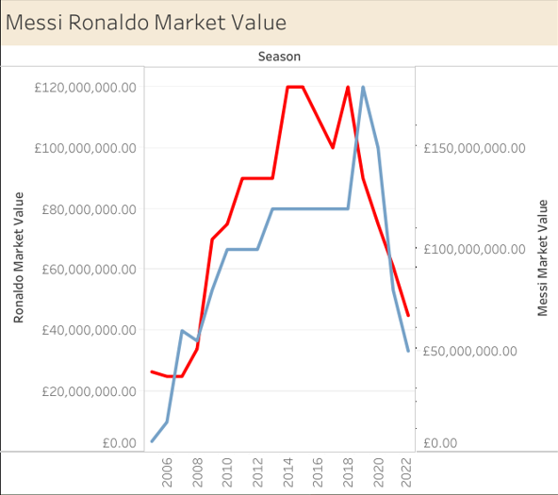
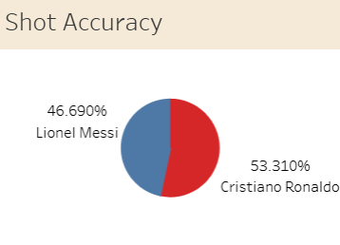
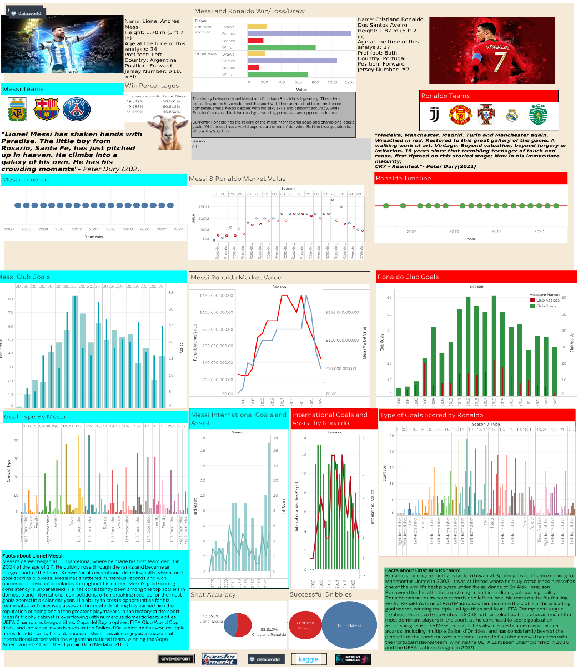
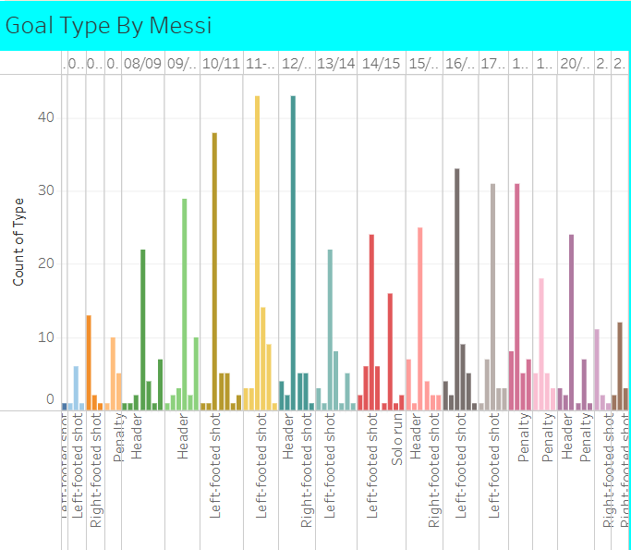

This information visualisation was taken from Tableau Public website, and it was published by Janoll Levy.
https://public.tableau.com/app/profile/janoll.levy/viz/LionelMessiandCristianoRonaldoComparativeAnalysis/Dashboard1

CRITIQUES POSSITIVE AND NEGATIVE
This information visualisation presents a comparative analysis of Lionel Messi and Cristiano Ronaldo across multiple performance metrics between 2006 and 2022. The dashboard aims to enable comparison through a combination of bar charts, line charts, bubble charts, and pie charts, covering aspects such as goal types, club goals, assists, market value, and shot accuracy. While the visualisation includes a wide range of comparative data, its effectiveness is mixed due to issues related to chart selection, colour encoding, legend clarity, and overall visual organisation. This critique evaluates the dashboard in terms of visual encoding, cognitive load, and perceptual clarity, highlighting both its strengths and its limitations.
One of the most problematic design choices in the dashboard is the use of pie chart to represent shot accuracy for Leonel Messi and Cristiano Ronaldo. Pie charts rely on angular and area perception, which is known to reduce perceptual accuracy when comparing values, particularly when the differences are relatively small. in this case the chart presents percentage of values without clearly communicating the total number of shots taken by each player, which can lead to misleading interpretations of performance. As a result, viewers may incorrectly assume that the underlying sample sizes are equivalent. A more effective alternative would be an aligned bar chart or a dot plot with a common, scale, which would support more precise comparison and reduce cognitive effort for the audience.
One of the most problematic elements of the dashboard is the bar chart titled Type of Goals by Leonel Messi, which attempts to represent multiple goal categories using a large number of bars and colours within a single view. although bar charts are suited for categorical comparison, this design suffers from excessive visual density, resulting in overplotting and increased cognitive load. The repeated labels and extensive use of colour create redundancy, as colour is used to encode categorical distinctions that are already represented by spatial position. This makes it difficult for viewers to accurately compare goal types or identify dominant categories. A more effective design would involve aggregating goal types into fewer, meaningful categories and sorting the bars by frequency or alternatively using small multiples to separate goal types across views. These approaches would reduce visual clutter and improve perceptual clarity.
The club goal charts for Messi and Ronaldo suffer from missing legend, making it difficult to distinguish between goals and assists. Both metrics are encoded using similar encoding and colour tones. as a result, viewers must rely on careful inspection rather than pre- attentive perception, increasing cognitive load and slowing comparison between players. this issue could be addressed using more distinct colour mappings, separating goals and assists and using legend would make it easier for the viewers.
In summary, the dashboard provides a large amount of comparative information and succeeds in presenting multiple perspectives on the performance of Messi and Ronaldo. However, several design choices reduce its overall effectiveness. Overcrowded charts, unclear religions and redundant color usage increase cognitive load and make accurate comparison difficult in certain views. Additionally, the inclusion of decorative elements in absence of a clear narrative structure weakens the dashboard's ability to communicate a coherent analytical story. With improved chart selection, clearer legends, reduced visual clutter and more effective support comparative analysis and deliver its intended message.

